

**Aakanksha Manoj Shirode**

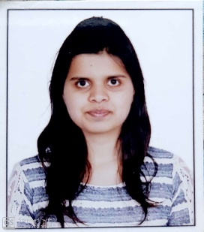**Address :** Flat No.3, Gokhale Park,

Rockel Lane, Ashok Stambh,

Nashik -422002

**Mobile :** (091) 7507495165

**E-mail :** aakankshashirode28@gmail.com

**Specialization :** Major:**Finance**

Minor:**Business Analytics**

**Career Objective:**

**To start / build career with an organization that can utilize my MANAGEMENT, FUNCTIONAL & ADMINISTRATIVE skills to benefit mutual growth and success**.



**Education Qualification:**

|  |  |  |  |  |
| --- | --- | --- | --- | --- |
| **Qualification** | **Institute** | **University/Board** | **Year of Passing** | **Passing (%)** |
| MBA (Finance) | Indira School of Business Studies, Pune | Pune university | 2019-2021 | Persuing |
| BE (Computer) | Matoshri College of Engineering and Research Centre, Nashik | Pune University | 2013-2017 | 67.53% |
| H.S.C | K.T.H.M College, Nashik | State Board | 2011-2013 | 72.00% |
| S.S.C | M.R. Sarda Kanya Vidya Mandir, Nashik | State Board | 2011 | 89.45% |



**Computer Skills:**

**Operating System :** Windows

**Packages Known :** MS Office (Word, PowerPoint, Excel)



**Additional Qualification / Professional Training or Certifications:**

* Certification in **Manual Testing**
* Certification in **Selenium WebDriver Testing**
* E-Certification in **C, Core Java, HTML, CSS**
* Certification in **German A-1 Level**



**Extra-Curricular Activities / Achievements:**

* Attended state level workshop on Compiler design and Data mining
* Secretary of **“Pinnacle Club”** at Matoshri college of Engineering
* Attended workshop on “Hadoop”
* Attended workshop on “Android”



**Personal Details:**

**Date of Birth :** 28 April 1996

**Marital Status :** Unmarried

**Strengths :** Collaborative Person

Sincere at my work

Hard working

**Languages Known :** English, Hindi and Marathi



**Declaration:** I hereby declare that the details furnished above are true and correct to the best of my knowledge and belief and I undertake to inform you of any changes therein, immediately.

**Place: Date: Signature:**